|  |
| --- |
| http://josetinoco.com |
| “The Dating Adventure” |
| **Game documentation** |
| Version 0.1  All work Copyright © 2016 by Joseph Tinoco.  All rights reserved. |
| **Joseph Tinoco** |
|  |



|  |
| --- |
| Feb 5th 2016 |

Contents

I. Game Overview 4

II. Game Play Mechanics 4

III. Controls 4

IV. Saving and Loading 5

V. Interface Sketch 5

VI. Menu and Screen Descriptions 6

VII. Game Progression 8

VIII. Power-ups 9

IX. Sound Index 9

X. Art / Multimedia Index 9

XI. Design Notes 9

XII. Future Features 9

**Version History**

V0.1 – Initial draft. Feb 02, 2015.

“The Dating Adventure” is a choose-your-own-adventure game within a dating context. It simulates the situations and decisions a person must go through in order to carry on a successful date night.

The game has an underlying educational objective: instruct players about the importance of *consent*, and how its absence can lead to issues like sexual assault or rape. This objective is intentionally not evident, but it is embedded in the game mechanics and final outcomes, in order to keep the player engaged in the adventure until the end. This prevents spooking users with an upfront serious theme and prevents reactions such as boredom or disinterest that usually come when users are faced with an educational game.

# Game Overview

The objective of the game is to carry on a successful date night with your partner, which means that, in the end, the player must *have sex with his/her date*.

To achieve this, the player is faced with several *scenes* typical of a date night, like going to a restaurant or watching a movie together. Each scene comes with a set of possible decisions, like holding your date’s hand or offering a drink, and those decisions determine the date sequence and the final outcome.

# Game Play Mechanics

Each game scene is presented through an image and a descriptive text, as well as two or more buttons with the player’s choices. The user must select one of the button choices to advance the game. There is no time limit to the user selection.

The game starts at an initial scene, with the first set of choices. From there onwards, the user is presented with a different scene, with different choices. Depending on the choices, the user may reach the same scene more than once.

When the user reaches a final outcome scene, he/she is presented with the results (positive or negative) of the play-through and is given the option to restart the game.

# Controls

The game is operated with either a mouse or touch screen, depending on the device. There is no need for keyboard support at this time.

# Saving and Loading

Saving and loading is not available, and player users are anonymous (i.e., there is no player login of any kind). If the game is interrupted in the middle of a play-through, the player must restart at the beginning.

# Interface Sketch

This is a preliminary sketch of one of the scenes. It contains the scene description (inside the orange box), three user action buttons (in blue) and the background image. Those are all configurable for each scene. The position of the elements is also configurable, to give the game some visual dynamics.

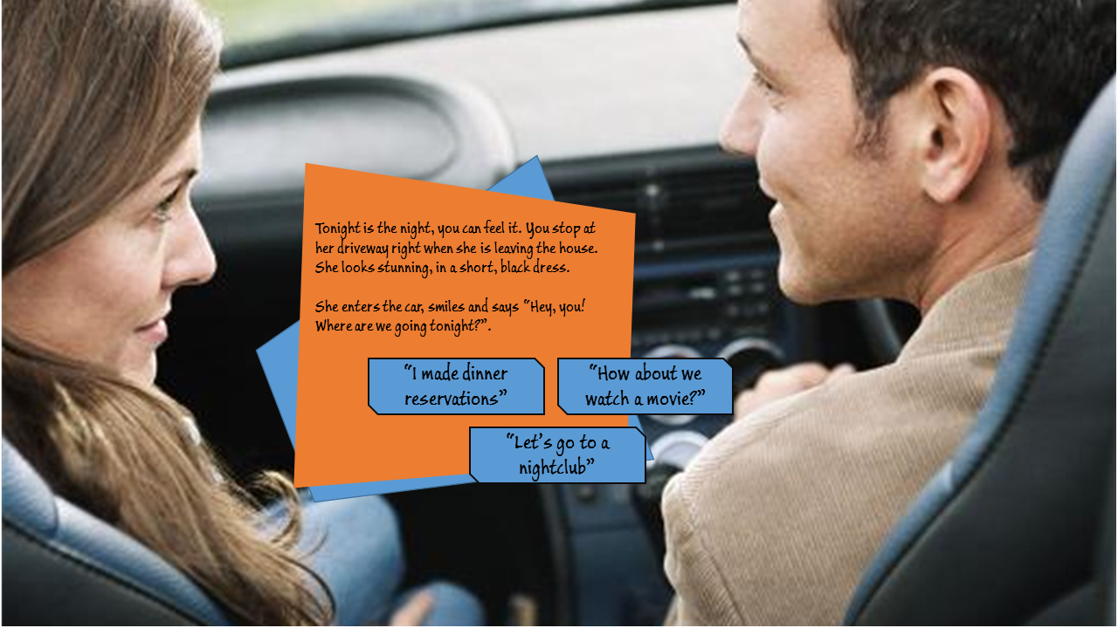

Figure - Game scene screen

# Menu and Screen Descriptions

The menu and final outcome screens follow the same visual identity, with some fundamental differences:

* The images are black and white
* The text box has a large title and only one color
* The user has only one button to choose from.

Below are some examples of the starting screen, a negative outcome screen and a positive outcome screen.



Figure - Game start screen



Figure - Negative outcome screen



Figure - Positive outcome screen

# Game Progression

Game progression is determined by user choices, as described by the state diagram below:

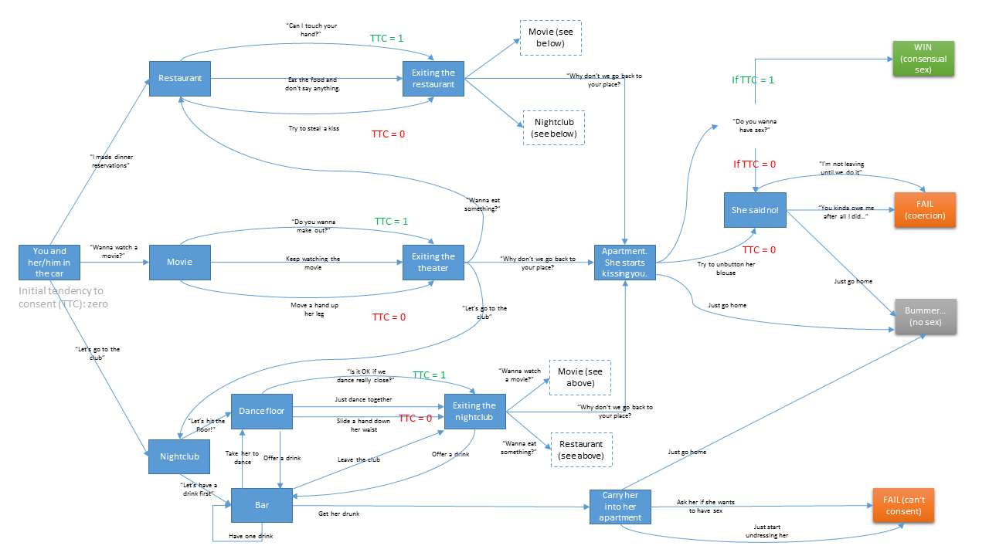

Figure - State diagram

The positive outcome is to reach the green state (consensual sex) shown on the diagram. The user can fall into three other final, negative states: attempting to coerce the partner, not having sex, or the partner is unable to consent (too drunk).

# Power-ups

In order to achieve the positive outcome, the player must have collected a “power-up” called **Tendency To Consent – TTC**. This is given to the player if he chooses alternatives where he verbally asks the date for permission before attempting something that might make the date uncomfortable, like touching or kissing. Conversely, this power-up is taken away from the player if he attempts to touch or kiss the date without asking for consent first.

This power-up is used at one of the final scenes of the game: the date’s apartment, when the player selects the option to ask the date if he/she wants to have sex. If, and only if, the player has the power-up, he can reach the positive outcome.

The alternatives that give or take away TTC are shown in the state diagram.

# Sound Index

*(To be included after the first alpha release)*

# Art / Multimedia Index

*(To be included after the first alpha release)*

# Design Notes

*(To be included after the first alpha release)*

# Future Features

* Make the game gender-neutral. This can be achieved by allowing the user to select his gender and the gender he/she is interested in, and editing game text on the fly (changing “he” to “she”, etc).
* Analytics: collect and store information about each play, how many scenes did the user see, his flow across the game state machine, if/when the player gave up playing, minutes spent in the app, etc.